

CACFP



**Snack Activities**

**Summer Is**

**Summer Activities**

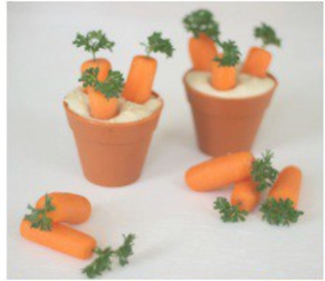

Let's Move CACFP! Hula Hoop Contests! Speed Walking Races! Gardening, try 3 Legged Races.

Growing Carrot Snack Pots

Via Foodlets.com

•Baby carrots, preferably the thick kind (some are whittled extra thin)

•Curly parsley

•Toothpick

•Terra cotta pots •Hummus

The season after spring and before fall, in which vegetation begins to appear, in the northern hemisphere from March to May and in the southern hemisphere from September to November.

“B is for Bloom”

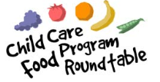

**New CACFP Meal Patterns Best Practice Ideas**

The updated CACFP Meal Patterns lays the foundation for a healthy eating pattern for children and adults in care. USDA has also developed optional best practices that build on the meal patterns and highlight areas where centers and day care homes may take additional steps to further improve the nutritional quality of the meals they serve.

* Register for training with your state agency or if a child care provider/center with your Food Program Sponsor.
* Support mothers who choose to breastfeed their infants by encouraging mothers to supply breastmilk for their infants while in day care and offer a quiet, private area that is comfortable and sanitary for mothers who come to the center or day care home to breastfeed.
* Make at least 1 of the 2 required components of a snack a vegetable or a fruit.
* Serve a variety of fruits and choose whole fruits (fresh, canned, dried, or frozen) more often than juice.
* Provide at least one serving each of dark green vegetables, red and orange vegetables, beans and peas (legumes), starchy vegetables, and other vegetables once per week
* Provide at least two servings of whole grain-rich grains per day.
* Serve only lean meats, nuts, and legumes.
* Limit serving processed meats to no more than one serving per week.
* Serve only natural cheeses and choose low-fat or reduced fat-cheeses.
* Serve only unflavored milk to all participants. If flavored milk is served to children 6 years old and older, or adults, use the Nutrition Facts Label to select and serve flavored milk that contains no more than 22 grams of sugar per 8 fluid ounces, or the flavored milk with the lowest amount of sugar if flavored milk within this sugar limit is not available.
* Serve water as a beverage when serving yogurt in place of milk for adults
* Incorporate seasonal and locally produced foods into meals.
* Limit serving purchased pre-fried foods to no more than one serving per week.
* Avoid serving non-creditable foods that are sources of added sugars, such as sweet toppings (e.g., honey, jam, syrup), mix-in ingredients sold with yogurt (e.g., honey, candy, or cookie pieces), and sugar sweetened beverages (e.g., fruit drinks or sodas).