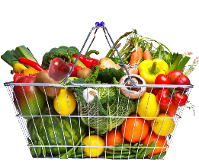
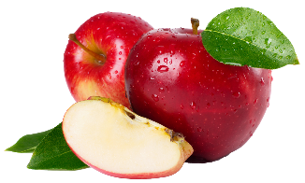
Healthy Snack Ideas
Choose Two food from Five groups:
Vegetables, Fruits, Grains/Bread, Meat/Meat Alternative, Fluid Milk

- Cucumber Coins + Whole Grain Crackers
- Yogurt + Mixed Fruit
- Bran Muffin + Milk
- Tuna Salad + Whole Grain Bagel
- Pita Bread + Hummus
- Cottage Cheese + Blueberries
- Whole Grain Tortilla + Egg Salad
- Bran Cereal + Sliced Strawberries
- Carrot Sticks + Whole Grain Crackers
- English Muffin + Tomato Sauce, Shredded Cheese, Veggies
- Applesauce + Whole Grain Toast
- Banana Bread + Cantaloupe
- Tomato Wedges + Cheese Slices
- Hardboiled Egg + English Muffin
- Whole Grain Chips + Mashed Avocado
- Snap Peas, Baby Carrots + Hummus
- Broccoli Florets + Whole Grain Crackers
- String Cheese + Mandarin Oranges
- Raspberries + Oatmeal
- Whole Grain Cheerios + Blackberries
- Baked Sweet Potatoes + Milk
- Scrambled Eggs + Tortilla
- Fresh Fruit + Cubed Cheese
- Cottage Cheese + Peaches
- Cauliflower Spears + Bread Sticks
- Whole Grain Toast + Grapes
- Cheese Cubes + Cherry Tomatoes
- Blueberry Muffins + Clementines
- Cucumbers, Jicama, Carrots + Hummus
- Apples + Cubed Cheese
- Yogurt + Papaya
- Baked Apples + Granola
- Peanut Butter, Raisins + Celery Sticks
- Chicken Salad + Whole Grain Crackers
- Frozen Banana + Yogurt
- Peanut Butter, Sliced Strawberries + Whole Grain Bread
- Whole Grain Tortilla, Refried Beans + Cheese
- White Bean Dip + Whole Grain Tortilla Chips
- Whole Grain Waffle + Mashed Blueberries
- Zucchini Bread + Yogurt
- Whole Grain Biscuit, Yogurt + Strawberries
- Hardboiled Egg + Ritz Crackers
- Cottage Cheese + Oranges
- Soybeans + Soft Pretzel
- Whole Grain Bagel + Hummus
- Peanut Butter, Whole Grain Tortilla, + Banana
- String Cheese + Plum
- Crushed Pineapple + Whole Grain Pancake
- Baked Potato + Cheddar Cheese
- Pumpkin Bread + Milk
- Frozen Melon Balls + Cottage Cheese
- Tuna Salad + Celery Sticks
- Dried Apricots + Whole Grain Crackers
- Apple Slices + Peanut Butter
- Croissant, Ham + Cheese
- Taro Bread + Mashed Blueberries
- Chicken Salad + Soda Crackers
- Zucchini Sticks + String Cheese
- Whole Grain Crackers + Melted Cheese
- Whole Grain Cheerios + Applesauce
- Kiwi + Ritz Crackers
- Cottage Cheese + Asparagus
- Watermelon + Whole Grain Cheerios
- Green Peas + Whole Grain Penne Pasta
- Rice Krispies Cereal, Raisins + Yogurt

