Ages: 1-2 3-5 6-12

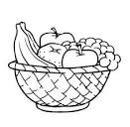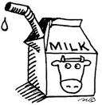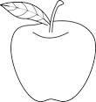

Food Chart

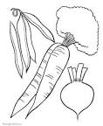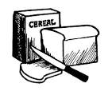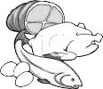

Child and Adult Care Food Program

Breakfast

1 Fluid Milk 1/2 cup 3/4 cup 1 cup

1 Vegetable/Fruit 1/4 cup 1/2 cup 1/2 cup

1 Grain/Bread

* Bread 1/2 slice 1/2 slice 1 slice
* Biscuit/Roll/Muffin/Cornbread 1/2 serving 1/2 serving 1 serving
* Cold Dry Cereal (flakes or rounds) 1/2 cup 1/2 cup 1 cup
* Hot Cooked Cereal 1/4 cup 1/4 cup 1/2 cup

This institution is an equal opportunity provider.

Maine Department of Health & Human Services

Office of Child and Family Services

(207) 624-7909

Snack (Select at least **two different components** from the following five)

1 Fluid Milk 1/2 cup 1/2 cup 1 cup

1 Fruit 1/2 cup 1/2 cup 3/4 cup

1 Vegetable 1/2 cup 1/2 cup 3/4 cup

1 Grain/Bread 1/2 slice or serving 1/2 slice or serving 1 slice or serving

1 Meat/Meat Alternate

* Cheese 1/2 oz. 1/2 oz. 1 oz.
* Large Egg 1/2 egg 1/2 egg 1/2 egg
* Peanut Butter or Nut/Seed Butters 1 Tbsp. 1 Tbsp. 2 Tbsp.
* Yogurt 1/4 cup 1/4 cup 1/2 cup
* Yogurts 2 oz. 2 oz. 4 oz.

Lunch/Supper

1 Fluid Milk 1/2 cup 3/4 cup 1 cup

1 Fruit 1/8 cup 1/4 cup 1/4 cup

1 Vegetable 1/8 cup 1/4 cup 1/2 cup

1 Grain/Bread

* Bread 1/2 slice 1/2 slice 1 slice
* Biscuit/Roll/Muffin/Cornbread 1/2 serving 1/2 serving 1 serving
* Pasta/Noodles/Grains 1/4 cup 1/4 cup 1/2 cup

1 Meat/Meat Alternate

* Meat/Poultry/Fish 1 oz. 1 ½ oz. 2 oz.
* Cheese 1 oz. 1 ½ oz. 2 oz.
* Large Egg 1/2 egg 3/4 egg 1 egg
* Cooked Dry Beans or Peas 1/4 cup 3/8 cup 1/2 cup
* Peanut Butter or Nut/Seed Butters 2 Tbsp. 3 Tbsp. 4 Tbsp.
* Tofu 1 oz. 1 1/2 oz. 2 oz.
* Yogurt 1/2 cup 3/4 cup 1 cup
* Alternate Protein Product 1 oz. 1 ½ oz. 2 oz.