FIVE MINI CULINARY DEMONSTRATIONS

Chef Michelle Bommarito

◦ Steel Cut Oatmeal Waffles
◦ Lentil Tofu Stew
◦ Caramelized Pinto Bean Burrito with Yogurt Tomato Salsa
◦ Black Bean Sweet Potato Patty
◦ Sweet Vanilla Chia Seed Pudding with Fresh Fruit

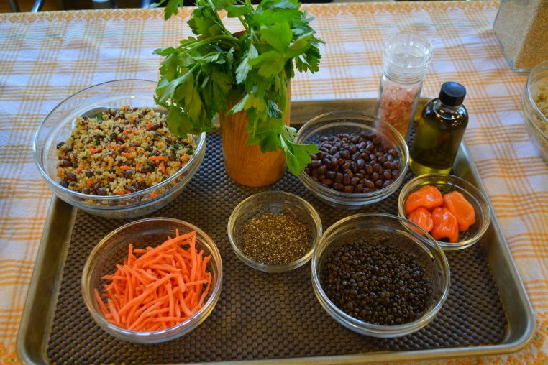

STEEL CUT OATMEAL WAFFLES

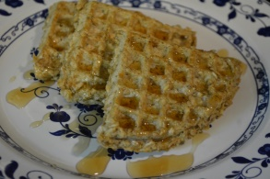
Ingredients:
Rolled Oats: 1-1/2 cup
Steel Cut Oatmeal: 3/4 cup
Eggs: 2 eggs, beaten
Himalayan Pink Salt

Place the rolled oats into a medium sauce pan and add in 3 cups of water. Soak overnight in the refrigerator.
Place the steel cut oats into a medium sauce pan and add in 1-1/2 cup of water. Soak overnight in the refrigerator.
The next day, bring the oats separately to a boil and lower to a simmer with the lid on. Allow to cook for approximately 2o minutes. Cool and Reserve.
In a large bowl, combine the oats and add in beaten eggs. Mix together well.
Using a waffle iron on medium heat, place 1/2 cup of mixture onto the hot iron. Press lightly and cook up firm and crispy.

Serve with Pure maple syrup or fresh fruit.

Steel Cut Oatmeal Waffles (approximations)
For Breakfast, Lunch, Snack or Supper

Ages one through two years:
Breads/Grains- 16 servings

Ages three through five years old:
Breads/Grains- 16 servings

Ages 6-12 year olds:
Breads/Grains- 8 servings

This recipe does not indicate how many waffles it makes.
The grains are not calculated to ounce equivalents.

LENTIL TOFU STEW

Carrots: 4 large, peeled and small dice
Celery: 5 stalks, small dice
Tofu: 2 packages, crumbled or diced
San Marzano Tomatoes: Low sodium, 2- 28 ounce cans/ crushed
Lentils: 1 pound, cooked
Himalayan Salt: to taste
Black Pepper
Extra Light Olive Oil
Extra Virgin Olive Oil
Pure Maple Syrup Grade B: Use if a sweeter taste is desired

In a large sauce pan over medium heat, add in 1 tablespoon of Extra light olive oil.
Add in the carrots and stir until golden brown.
Then add in the celery and combine well.
Add in the crumbled pieces of tempeh and allow to get golden brown.
Add in the tomatoes and stir well.
Add in the lentils and combine. Allow to cook together for 10 minutes at a simmer.
Add in salt , pepper to taste. Drizzle in Extra Virgin Olive Oil and Pure Maple Syrup.
Serve over a bed of short grain brown rice.
Lentil Tofu Stew (approximations)
For Lunch or Supper

Ages one through two years:
Meat/meat alternate- 29 servings (1/4 cup)
Fruit/Vegetable- 64 servings (1/8 cup), (1/4 cup total needed)

Ages three through five years old:
Meat/meat alternate- 19 servings (3/8 cup)
Fruit/Vegetable- 32 servings (1/4 cup), (1/2 cup total needed)

Ages 6-12 year olds:
Protein/meat alternate- 14 servings (1/2 cup)
Fruit/Vegetable- 32 servings (1/4 cup), (¾ cup total needed) OR 16 servings (1/2 cup)

The tofu in this recipe is an extra and will not count as protein until 10/1/2017. The vegetable serving amount can vary as a portion of the total.

CARAMELIZED PINTO BEAN BURRITO WITH YOGURT TOMATO SALSA

Pinto Beans: 2 cups
Water/vegetable broth or herbal or green tea: 6 cups
Extra light olive oil (In a misting spray bottle)
Extra virgin olive oil
Himalayan pink salt

Rinse beans in a large bowl of cold water and remove any impurities.
Soak the beans in a covered container overnight in the refrigerator. For larger beans soak for 2 nights. Additional water may be necessary. (Ratio for soaking is 3 cups of water to 1 cup of beans).
Remove from the refrigerator and drain soaking water.
Place the beans in a large stock pot. Cover beans with twice the height with cold water or any desired cooking liquid.
Bring the beans to a boil. At the boil, lower to a simmer and cover with a lid.
Allow the beans to cook until “al dente”…(depending on the size of the bean, the cooking time can range from 45 minutes to 1-1/2 hours).
Remove from heat, drain and rinse under cold water. Reserve.

METHOD FOR CARAMELIZING:

Take a saute pan and heat over medium heat. Using a mister bottle, spray in extra light olive oil.
Add in a small amount of cooked beans. With a meat pounder, wooden spoon or high heat spatula, gently press the beans in a random fashion.
Add in more beans and continue the above process. Make sure to allow some beans to remain whole for texture.
Remove from heat and drizzle with extra virgin olive oil and himalayan pink salt and any other desired seasonings…serve with a whole wheat tortilla, tomatoes lettuce and greek yogurt.

*Any bean taste delicious with this cooking method.
Caramelized Pinto bean Burrito with Yogurt Tomato Salsa (approximations)
For Lunch or Supper for the beans only

Ages one through two years:
Meat/meat alternate- 21 servings (1/4 cup)

Ages three through five years old:
Meat/meat alternate- 14 servings (3/8 cup)

Ages 6-12 year olds:
Protein/meat alternate- 10 servings (1/2 cup)

BLACK BEAN SWEET POTATO PATTY

Black Beans: 1-1/2 cups dry and cooked or 3 cups canned
Sweet Potato: 2 cups, cooked/approximately 2 large
Rolled Oats: 3/4 cup
Vegetable Broth or Water: 1-1/2 cup
Tomato Paste Low Sodium: 2 Tablespoons
Eggs: 2 whole
Himalayan Pink Salt:

Rinse beans in a large bowl of cold water and remove any impurities.

Soak the beans in a covered container overnight in the refrigerator. For larger beans soak for 2 nights. Additional water may be necessary. (Ratio for soaking is 3 cups of water to 1 cup of beans).
Remove from the refrigerator and drain soaking water.
Place the beans in a large stock pot. Cover beans with twice the height with cold water or any desired cooking liquid.
Bring the beans to a boil. At the boil, lower to a simmer and cover with a lid.
Allow the beans to cook until “al dente”…(depending on the size of the bean, the cooking time can range from 45 minutes to 1-1/2 hours). Remove from heat, drain and rinse under cold water. Puree half the beans. Reserve.
Scrub the skin of the sweet potatoes under cold water using an allocated kitchen brush. Oven roast the potatoes whole at 375 degrees F for approximately 45 minutes. Allow to cool and then remove the skin. Remove the flesh. Reserve.
Place the Rolled Oats in medium sauce pan and add in the vegetable broth or the water. Bring to a boil and then cover with a lid and simmer for approximately 20 minutes. Reserve.

In a small bowl, beat the 2 eggs together with a whisk. Reserve.
In a large bowl combine the beans, sweet potatoes, cooked rolled oats and tomato paste. Using a rubber spatula “fold” the ingredients together.
Add in the beaten eggs and any desired seasoning such as salt, cumin and black pepper.
Form the mixture into desired size patties and place on a sheet pan lined with parchment paper.

Bake at 375 degrees F for approximately 3o minutes.
Serve as is or with a multi grain bun and lettuce, tomato and any other desired condiments.
Black Bean Sweet Potato Patty (approximations)
For Lunch or Supper for the patty only

Ages one through two years:
Meat/meat alternate- 16 servings
Fruit/Vegetable- 16 servings (1/8 cup), (1/4 cup total needed)
Breads/Grains- 6 servings

Ages three through five years old:
Meat/meat alternate- 10 servings
Fruit/Vegetable- 8 servings (1/4 cup), (1/2 cup total needed)
Breads/Grains- 6 servings

Ages 6-12 year olds:
Protein/meat alternate- 8 servings
Fruit/Vegetable- 8 servings (1/4 cup), (¾ cup total needed) OR 4 servings (1/2 cup)
Breads/Grains- 3 servings

The vegetable serving amount can vary as a portion of the total.

*One serving would be one creditable portion of the minimum requirement, of course some children will eat more than the minimum portion.

